**CERTIFICATE**

OF PARTICIPATION

The following is awarded to

{Name}

For successfully participating in **Introduction to Python Learning Program** (January’23 – March’23) on **Meraki E-Learning Platform**.

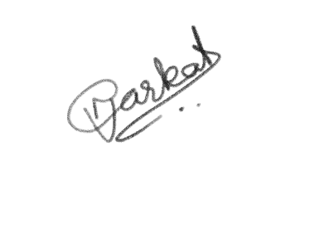

***Nidhi Anarkat******CEO & Co-Founder***